Osemsmerovky – vianočné Meno: ...............................................................
2.
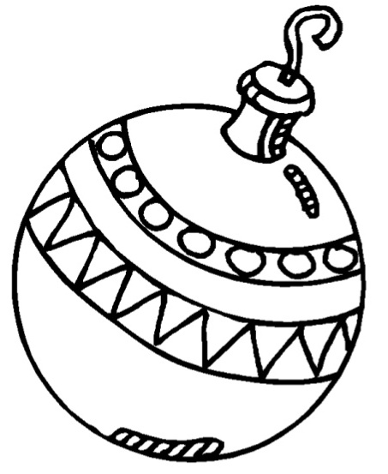







1.
Vyškrtaj všetky slová a potom daj do krúžku nevyškrtané písmená. Tie tvoria čítaním po riadkoch tajničku.
S | M | R | Á | D | N | E | L | A | K
Y | V | I | V | I | K | Ľ | Á | R | K
B | K | I | S | C | K | L | Á | V | A
U | S | A | A | K | E | S | E | N | O
Z | U | T | R | T | A | T | E | P | Ť
A | K | R | O | M | K | M | E | L | S
J | K | O | S | Y | Z | Y | A | T | E
A | O | T | S | E | M | T | B | E | Š
C | O | O | M | A | K | C | A | R | P
E | N | E | M | A | K | A | Ž | O | K
STO, TORTA, KOSY, MRAKY, KALENDÁR, KRÁSA, MISKA, ZUBY, LATKA, KIVI, KRÁĽ, LESK, LÁVA, ŠTETEC, SENO, ŠESŤ, NOSY, PLTE, ZMENA, PRACKA, ŽABA, KOŽA, MESTO, KAMENE, ZAJACE, ZEM,
MORKA, KUS
P | K | A | I | L | U | H | E | N | S
A | O | A | M | A | L | T | U | T | A
P | Z | K | Ň | E | M | E | R | R | N
M | A | A | O | A | S | O | Č | H | K
A | R | L | M | J | M | E | S | O | Y
L | B | A | I | A | A | E | B | T | A
M | O | K | I | C | J | R | S | I | C
J | I | S | O | E | A | A | O | T | E
Á | U | E | M | N | E | I | V | E | V
M | U | Ž | R | A | E | R | A | D | U
VIE, DETI, DVAJA, KOBRA, SÁNKY, VEC, DAR, LAMPA, SNEHULIAK, STROM, SOVA, KRUH, TRH, MÁJ, TLAMA, LEČO, OSEM, SKALA, REMEŇ, MOST, OSA, OBRAZ, PALICA, MUŽ, JAMA, SEJEM, KONE, CENA, MUSIA

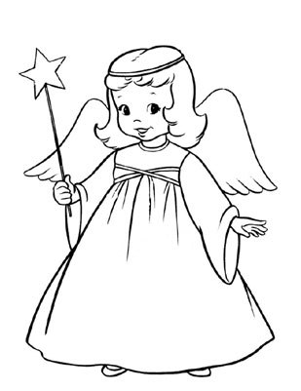
TAJNIČKA:
VIANOCE SÚ ......................................................

................................................................................................

